Maskine
Biceps / Triceps  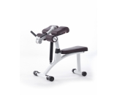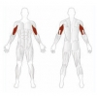 | Belastning:  Gentagelser:
Shoulder Press / Lat Pull  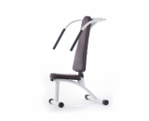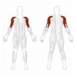 | Belastning:  Gentagelser:
Abductor / Hip Adductor  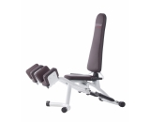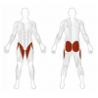 | Belastning:  Gentagelser:
Chest / Back  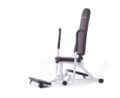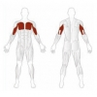 | Belastning:  Gentagelser:
Twisting  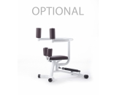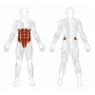 | Belastning:  Gentagelser
Back Extension  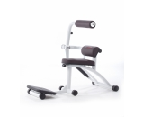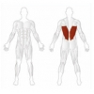 | Belastning:  Gentagelser:
Leg Extension / Leg Curl  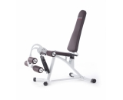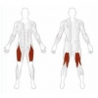 | Belastning:  Gentagelser:
Abdominal / Back  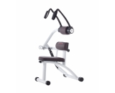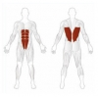 | Belastning:  Gentagelser:
Pec Dec / Fly  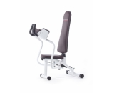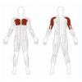 | Belastning:  Gentagelser:
Leg Press  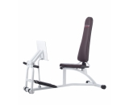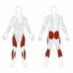 | Belastning:  Gentagelser:

Kommentar: __________________________________________________________________________________________________________________________________________________________________________________________________________________________________________________________________________________________________________________________________________________________________________________________________________________________________________________________________________________________________________________________________________________________________________________________

